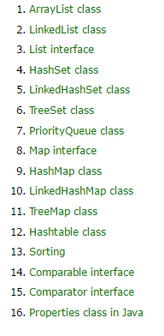

Collections in Java->

*Collections in java is a framework that provides an architecture to store and manipulate the group of objects.

*All the operations that you perform on a data such as searching, sorting, insertion, manipulation, deletion etc. can be performed by Java Collections.

*Java Collection simply means a single unit of objects.

* Java Collection framework provides many interfaces (Set, List, Queue, Deque etc.) and classes (ArrayList, Vector, LinkedList, PriorityQueue, HashSet, LinkedHashSet, TreeSet etc).

#### **What is Collection in java?**

**->Collection represents a single unit of objects i.e. a group.**

#### **What is framework in java?**

* ->provides readymade architecture.
* represents set of classes and interface.
* is optional.

### **Hierarchy of Collection Framework->**

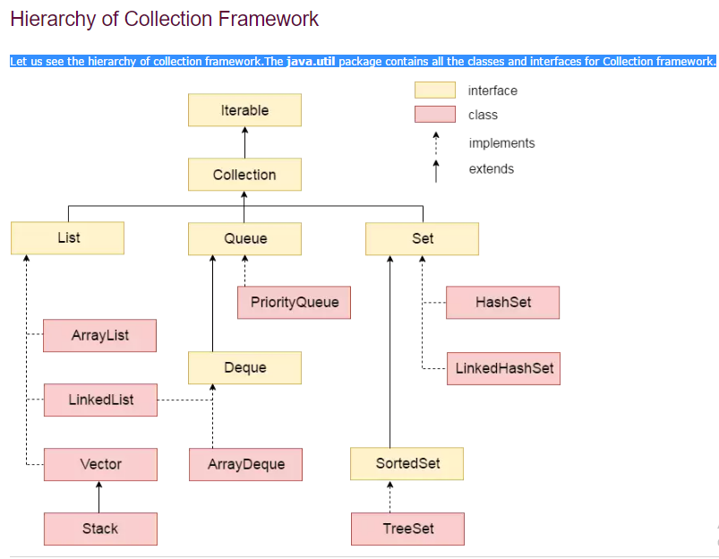

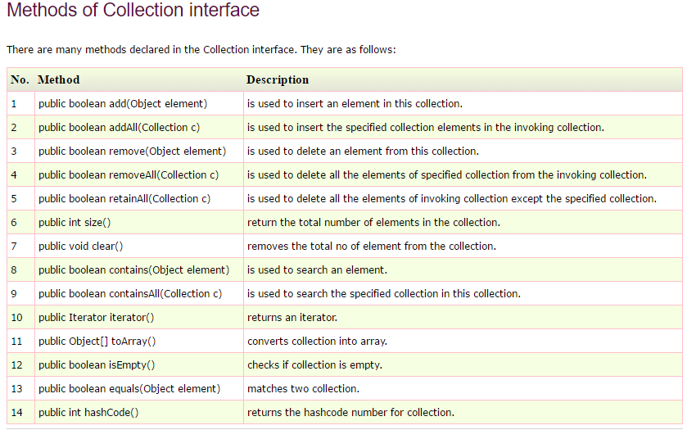

Priority queue-> In computer science, a **priority queue** is an abstract data type which is like a regular **queue** or stack data structure, but where additionally each element has a "**priority**" associated with it. In a **priority queue**, an element with high **priority** is served before an element with low **priority**. In computer science, a **priority queue** is an abstract data type which is like a regular **queue** or stack data structure, but where additionally each element has a "**priority**" associated with it. In a **priority queue**, an element with high **priority** is served before an element with low **priority**.

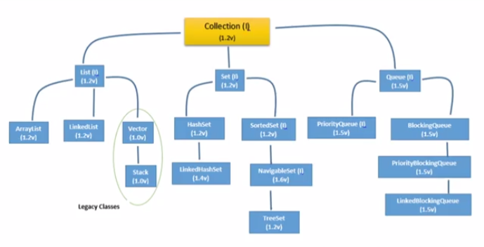

### **Iterator interface->**

Iterator interface provides the facility of iterating the elements in forward direction only.